1. Introduction

1.1 Introduction to the Problem
In the rapidly evolving landscape of bioinformatics and precision medicine, Machine Learning (ML) has emerged as a pivotal tool for deciphering complex biological data. While traditional ML models have achieved remarkable success in diagnosing common diseases where vast amounts of labeled data are available, they often falter when applied to rare genetic diseases. Rare diseases, by definition, have a low prevalence, resulting in a severe scarcity of data for individual conditions. This phenomenon creates a "long tail" distribution where the majority of diseases have very few diagnosed cases, making standard supervised learning techniques inefficient or prone to overfitting.
A significant compounding factor in this domain is the fragmentation of data. Information regarding gene characteristics, phenotypes, and disease associations is often scattered across disparate repositories, making it difficult to train unified models. The core challenge addressed in this thesis is the classification of these rare genetic disorders by overcoming both data scarcity and data fragmentation.
To tackle this, we propose the application of Contrastive Learning, a paradigm that focuses on learning representations by comparing similar and dissimilar pairs of data points. We utilize a custom-curated dataset that integrates gene metadata (such as location and exon count) with phenotypic ontology terms. By leveraging the structure of these relationships—pulling genes with similar phenotypic profiles closer together in the embedding space—we aim to build a robust model capable of classifying rare genes even when training samples are scarce. This research explores how such representation learning can bridge the gap between fragmented, low-volume data and accurate medical diagnosis.

1.2 Motivation
There are estimated to be over 7,000 distinct rare diseases affecting hundreds of millions of people globally. For patients suffering from these conditions, the path to a correct diagnosis is often a "diagnostic odyssey"—a journey involving years of misdiagnoses and ineffective treatments. A primary bottleneck is the lack of a centralized, holistic view of the data; vital information is often siloed in separate databases like NCBI, HPO, or DisGeNET.
From a computational perspective, standard Deep Learning models are "data hungry" and struggle to find decision boundaries with only a handful of positive examples. In the context of rare diseases, finding even fifty confirmed cases for a specific gene mutation can be impossible. This discrepancy motivates the need for a learning paradigm that is "data efficient."
We are motivated by the hypothesis that constructing a comprehensive dataset—combining structural gene attributes (e.g., Chromosome, Exon Count) with deep phenotypic descriptions (HPO terms)—will allow a Contrastive Learning model to capture subtle patterns that standard classifiers miss. By focusing on the intrinsic similarities between these rich feature sets rather than just categorical labels, the model can learn useful features from smaller datasets. The potential to shorten the diagnostic odyssey by synthesizing scattered data into a predictive tool serves as the primary driving force behind this research.

1.3 Objectives
The primary objective of this thesis is to develop a machine learning framework capable of accurately classifying rare genetic diseases by utilizing contrastive learning on a custom-integrated dataset. To achieve this, we have outlined the following specific goals:
- Custom Dataset Construction: To aggregate and harmonize data from multiple authoritative sources—specifically the National Center for Biotechnology Information (NCBI), Human Phenotype Ontology (HPO), and DisGeNET—to create a unified dataset containing official gene symbols, locations, exon counts, and associated HPO terms.
- Feature Engineering: To preprocess and encode heterogeneous features, including categorical data (e.g., Chromosome, Gene Type) and ontology-based identifiers (e.g., HP:0001945), transforming them into a format suitable for neural network input.
- Implementation of Contrastive Learning: To design and implement a neural network architecture that utilizes contrastive loss functions to learn high-quality vector embeddings, effectively clustering genes based on the similarity of their phenotypes and structural attributes.
- Model Optimization: To experiment with different contrastive strategies to determine the most effective method for separating distinct rare disorders in the latent space.
- Performance Evaluation: To evaluate the model’s classification accuracy and precision, specifically testing its performance on "few-shot" scenarios (diseases with very limited data) to quantify the improvements gained over traditional baseline methods.

2.Literature Review
The classification of rare genetic disorders presents unique challenges in bioinformatics due to the "long-tail" distribution of disease prevalence and the fragmentation of biological data. This review examines the evolution of Machine Learning (ML) strategies from standard supervised approaches to Self-Supervised Learning (SSL), specifically Contrastive Learning (CL), and their application in medical diagnostics, genomic analysis, and rare disease classification.

2.1 The Shift to Contrastive Self-Supervised Learning
Traditional supervised learning relies heavily on large-scale, annotated datasets. However, in the medical domain, and particularly for rare diseases, obtaining high-quality labeled data is often cost-prohibitive or impossible due to patient scarcity.
Jaiswal et al. [1] provide a comprehensive survey of Contrastive Self-Supervised Learning, highlighting its ability to learn robust representations without explicit labels. The core principle involves pulling "positive" pairs (e.g., augmented views of the same sample) closer in the embedding space while pushing "negative" pairs apart. This is typically achieved using the InfoNCE (Information Noise-Contrastive Estimation) loss function, which maximizes the mutual information between augmented views. Architectures such as SimCLR, MoCo, and BYOL have demonstrated that models trained on pretext tasks (such as rotation prediction or color jittering) can learn invariant features that generalize remarkably well to downstream tasks. This paradigm is particularly relevant to our research, as it offers a mathematical framework to handle class imbalance by focusing on feature distinguishability rather than class probability alone.

2.2 Contrastive Learning in Medical Imaging
The majority of current research applying Contrastive Learning to healthcare focuses on Medical Imaging (MRI, PET, Dermoscopy). These studies validate the efficacy of CL in extracting diagnostic features from complex, noisy biological data.
Alzheimer’s Disease (AD) Classification: Several studies have successfully utilized CL for neurodegenerative disorders. Fiasam et al. [2] proposed Domain Contrastive Learning (DCL) to address the variability in MRI data across different clinical sites. By aligning feature distributions from multiple domains, they improved model transferability. Similarly, Chen et al. [3] applied contrastive strategies to 18F-FDG PET imaging. They addressed the issue of small sample sizes and low signal-to-noise ratios in PET scans by generating extended training data through cropping and adopting a contrastive loss that minimizes intra-class differences while maximizing inter-class distances.
Dermatological Classification: In the domain of skin disease, Aboulmira et al. [4] demonstrated that Contrastive Learning significantly enhances classification performance compared to traditional Cross-Entropy methods. Their work highlighted the model's ability to differentiate between visually similar skin lesions by learning fine-grained feature representations, a crucial capability when dealing with diseases that share overlapping phenotypic characteristics.

2.3 Multimodal and Genomic-Aware Architectures
While imaging-based CL is well-established, integrating genomic and non-image data remains a developing frontier.
Multimodal Integration (ContIG): Taleb et al. [5] introduced ContIG, a framework for Self-Supervised Multimodal Contrastive Learning. This method aligns medical images with genetic data in a shared feature space. By integrating six genetic modalities (including SNPs and CNVs) with retinal images, ContIG demonstrated that leveraging the interplay between phenotype (image) and genotype (genetics) enhances performance on downstream tasks. However, this approach still relies heavily on the availability of dense imaging data, which is often unavailable for rare genetic disorders defined primarily by clinical ontology terms.
Gene Networks and Ontology (CoGO): Closer to the text-based nature of genetic classification, Chen et al. [6] proposed CoGO, a contrastive framework for predicting disease similarity. CoGO utilizes Gene Ontology (GO) graphs and gene interaction networks to learn low-dimensional representations of diseases. By employing a graph-based contrastive approach, they successfully identified relationships between diseases based on molecular mechanisms. While CoGO validates the use of graph structures in CL, its primary focus is on measuring similarity rather than the direct classification of disorders based on ragged phenotypic inputs.

2.4 Challenges in Rare Disease Classification
The application of Machine Learning to rare genetic diseases has been extensively studied, yet significant hurdles remain. Roman-Naranjo et al. [8] conducted a systematic review of ML approaches in this domain, concluding that while techniques like Random Forests and Support Vector Machines (SVMs) have improved diagnostic yields, they often struggle with the high dimensionality of genomic data and the phenotypic heterogeneity of rare conditions. Their review emphasizes that "one-size-fits-all" models are insufficient and highlights the critical need for integrative models that can handle diverse and fragmented biological data sources.
This classification challenge is further complicated by data privacy and scarcity. Siganporia et al. [7] explored Privacy-Enhanced Federated Learning for rare genetic disorders using Electronic Health Records (EHR). Their work highlights the "data scarcity" issue, where individual hospitals lack sufficient cases to train robust models. They utilized a federated approach where local model updates are aggregated to a global model without exchanging raw patient data. While this addresses privacy, they rely on standard supervised classification heads which may struggle with the extreme class imbalance inherent to rare diseases.

2.5 Summary and Research Gap
The literature establishes that Contrastive Learning is a powerful tool for handling unlabeled data and class imbalance. However, a distinct gap exists:
- Modality Gap: Most medical CL research focuses on dense pixel data (Images) or continuous signals. There is limited research on applying CL to "ragged" discrete data, such as variable-length lists of HPO (Human Phenotype Ontology) terms and Exon counts.
- Application Gap: While ContIG integrates genetics with images, and CoGO looks at disease similarity, there is a lack of unified frameworks specifically designed to classify rare diseases by learning directly from the fragmented relationship between Gene Metadata and Phenotypic Ontologies.
This thesis addresses these gaps by developing a Contrastive Learning framework specifically tailored for non-image, variable-length biological data to improve the diagnosis of rare genetic disorders.

3.Proposed System

3.1 Workflow Diagram
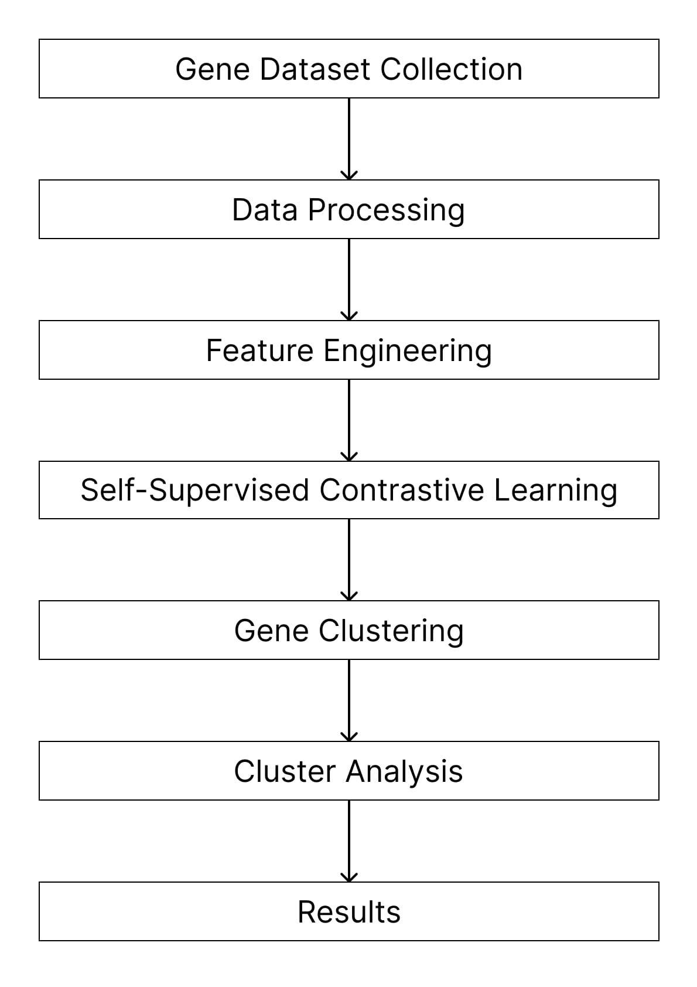
The proposed system follows a sequential pipeline designed to transform fragmented, raw biological data into meaningful disease clusters. The workflow is divided into five critical stages:

- Data Integration: Merging gene, disease, and phenotype data into a unified matrix.
- Feature Engineering: Creating a hybrid feature set that combines clinical symptoms (phenotypes) with biological attributes (gene structure).
- Self-Supervised Contrastive Learning: Training a neural network to learn robust representations by maximizing the similarity between augmented views of the same gene.
- Clustering: Grouping genes based on the learned "fingerprints" (embeddings).
- Visualization & Analysis: Validating the clusters using dimensionality reduction and biological interpretation.

3.2 Chosen Machine Learning Method
The core methodology chosen for this research is Self-Supervised Contrastive Learning, specifically adapted for genomic data using the SimCLR (Simple Framework for Contrastive Learning of Visual Representations) paradigm.
Unlike traditional supervised learning, which requires explicit labels for every sample (often unavailable for rare diseases), this method learns by comparison. The model does not initially know which gene causes which disease. Instead, it learns a "disease space" through the following mechanism:
- Positive Pairs: Two artificially altered views of the same gene (e.g., one with missing symptoms, one with noise added). The model is trained to recognize that these two views represent the same biological entity.
- Negative Pairs: Views of different genes. The model is trained to distinguish these from the positive pair.
By forcing the model to pull positive pairs together and push negative pairs apart in the embedding space, the system learns to identify the intrinsic features that define a gene's pathological profile.

3.3 System Performance Factors
The performance of the proposed system relies on three critical factors:
- Augmentation Quality: Since the dataset is small (25-300 genes), the ability of the model to generalize depends on how well the data augmentation (masking and noise injection) simulates real-world biological variability.
- Embedding Dimensionality: The size of the latent vector (set to 128) must be large enough to capture complex gene-phenotype relationships but small enough to avoid the "curse of dimensionality" during clustering.
- Clustering Algorithm Selection: The choice of Hierarchical Agglomerative Clustering is critical because biological taxonomies are naturally hierarchical (e.g., Cancer $\rightarrow$ Blood Cancer $\rightarrow$ Lymphoma), making it superior to flat clustering methods like K-Means for this domain.

4.Dataset Analysis

4.1 Source and Credibility of Datasets
Unlike standard machine learning domains where pre-compiled datasets are readily available, the field of rare genetic diseases suffers from severe data fragmentation. No single repository currently contains the comprehensive mapping of gene attributes, phenotypic associations, and disease classifications required for this research. Consequently, we constructed a custom dataset by aggregating and harmonizing data from three authoritative biological databases:
- National Center for Biotechnology Information (NCBI): This served as the primary source for official gene nomenclature, chromosomal locations, and structural gene attributes (such as exon counts).
- DisGeNET: Used in conjunction with NCBI to verify gene-disease associations and obtain official gene symbols.
- Human Phenotype Ontology (HPO) / hpo.jax.org: The authoritative source for standardized phenotypic terminology. This provided the critical semantic link between genetic markers and observable clinical features (phenotypes).
By cross-referencing these globally recognized databases, we ensured the credibility and medical accuracy of the data. The final dataset integrates structural biological data with clinical phenotypic descriptions, creating a unified resource suitable for contrastive learning.

4.2 Dataset Statistics and Description

The dataset consists of 10 distinct attributes per record, categorized into Gene Identification, Structural Attributes, and Clinical Associations.
Current Data Volume:
As of this reporting phase, the pilot dataset includes 25 distinct genes serving as the initial seed for our model. These genes are linked to a rich set of clinical features, comprising 100 distinct disease entities and 2043 total HPO associations (of which approximately 1100 are unique phenotypic terms). The final target for the completed thesis is to scale this dataset to include 300 distinct genes, providing a broader coverage of the rare disease landscape.
Feature Description:
Below is a description of each feature included in our analysis:
Attribute Name | Category | Description
Official Full Name of Gene | Gene ID | The complete, biologically standardized name of the gene (e.g., BCL2 apoptosis regulator).
Official Symbol of Gene | Gene ID | A unique, short-form alphanumeric identifier (e.g., BCL2). This symbol links data across databases.
Gene Type | Structural | Classifies the gene based on function (e.g., "protein-coding," "ncRNA").
Location | Structural | The specific cytogenetic location on the chromosome (e.g., 18q21.33).
Exon Count | Structural | A numerical value indicating the number of coding regions in the gene structure.
Chromosome | Structural | Indicates the chromosome number (1-22, X, Y) where the gene resides.
HPO Association | Clinical | The descriptive name of the phenotype (e.g., Abnormal peritoneum morphology).
HPO Term Identifier | Clinical | The unique ID assigned by the Human Phenotype Ontology (e.g., HP:0002585).
Disease Name | Clinical | The specific rare genetic disorder linked to the gene (e.g., Follicular lymphoma).
Disease Identifier | Clinical | The unique accession number (e.g., ORPHA:545) identifying the disease entity.

4.3 Anomalies and Challenges in the Dataset

During the data aggregation and inspection process, we identified specific structural imbalances and anomalies. Addressing these is critical for the robustness of our Contrastive Learning model.
1. Variable Density of Phenotypic Associations (Ragged Data)
The most significant anomaly observed is the lack of uniformity in the number of associations per gene.
- Observation: The depth of clinical annotation varies wildly between genes. For instance, a well-documented gene in our dataset is associated with over 100 HPO terms, while a less studied gene may only have 15 terms. Similarly, disease associations are uneven; one gene may be linked to 5 different disease variants, while another is linked to only a single specific disorder.
- Impact: This creates a "ragged" data structure where input vectors are of variable length. Standard neural networks typically require fixed-size inputs, necessitating a specialized pooling or encoding strategy to handle these variable feature sets.
2. Class Imbalance (Phenotypic Rarity)
There is a distinct imbalance in the frequency of specific phenotypic features.
- Observation: Common phenotypes (e.g., terms related to "Kidney" abnormalities) appear in roughly 100 samples, whereas rarer, more specific phenotypes (e.g., "Metabolic" terms) may only appear in 5 samples.
- Impact: This imbalance risks biasing the model towards common symptoms while ignoring rare but diagnostic features. The contrastive learning approach is specifically chosen to mitigate this by focusing on relative similarity rather than absolute frequency.
3. Data Cleaning and Integrity
Due to the automated nature of merging data from different sources, some records initially contained empty or impossible values (e.g., missing Exon Counts).
- Handling: To maintain integrity, we performed rigorous data cleaning. We skipped records with impossible or empty values during the scraping process.
- Consequently, the final dataset contains only fully populated, verifiable biological instances.

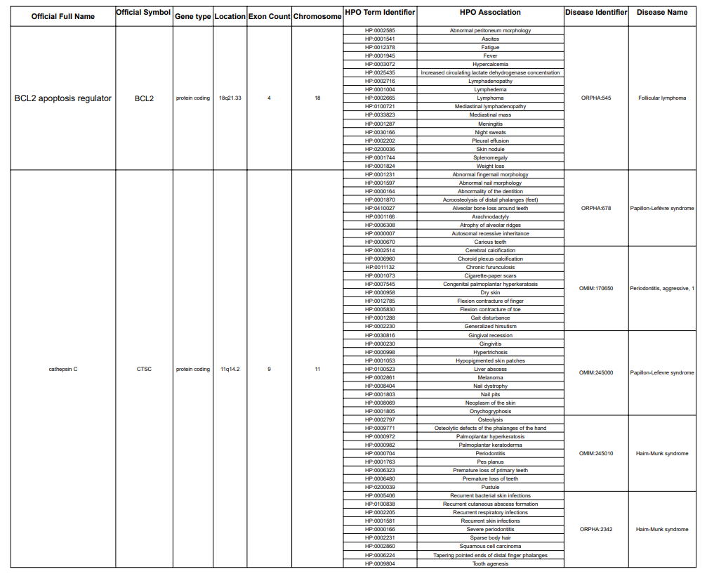

5. System Implementation

5.1 Data Preprocessing
The raw data from NCBI, DisGeNET, and HPO was processed to create a unified input tensor.
- Handling Ragged Data: Since genes have varying numbers of symptoms, we implemented Multi-Hot Encoding. A binary vector of size 1,318 (representing all unique HPO terms) was created for each gene, where a '1' indicates the presence of a symptom.
- Hybrid Features: We concatenated this phenotype vector with structural data:
  - Chromosome: Label encoded (1-22, X, Y).
  - Gene Type: Label encoded (e.g., protein-coding).
  - Exon Count: Normalized numeric value (imputed with median for missing values).
- Normalization: The final feature matrix was passed through a Standard Scaler to normalize distributions (mu=0, sigma=1), ensuring stable training dynamics.

5.2 Data Augmentation Strategy
To implement self-supervision, a custom Gene Augmentation class was developed. This module generates two unique views for every gene during training:
- Phenotype Masking: A dropout mechanism that randomly zeros out 15% of the active phenotype features (p=0.15). This forces the network to recognize the gene even when clinical data is incomplete or fragmented.
- Noise Injection: Gaussian noise (mu=0, sigma=0.1) is added to the continuous features (Exon Count) to prevent the model from memorizing exact values.

5.3 Model Architecture
The neural network was constructed using PyTorch nn.Module with an Encoder-Projector design.
- Encoder Network: A Multi-Layer Perceptron (MLP) with layers [Input -> 512 ->256 ->128]. We utilized Batch Normalization and ReLU activation after each layer to prevent vanishing gradients.
- Projection Head: A temporary layer [128 ->128 -> 64] used only during training to calculate the contrastive loss, mapping representations to the space where the contrastive loss is applied.

5.4 Training Process
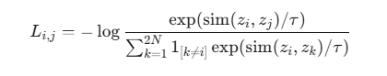
The model was trained for 200 epochs with a batch size of 16 to ensure stability on the small dataset. We utilized the Adam optimizer (Learning Rate = 0.001) and the Normalized Temperature-scaled Cross Entropy (NT-Xent) loss function.

This loss function calculates the probability that sample i and sample j are a positive pair, normalized by the similarity of sample i to all other samples in the batch.

5.5 Embedding Extraction
Post-training, the projection head was discarded. The dataset was passed through the frozen Encoder to generate 128-dimensional embeddings for every gene. These embeddings represent the model's learned understanding of the gene's "location" in the disease landscape.

5.6 Clustering Analysis
To group the genes into meaningful disease categories, we applied clustering to the extracted embeddings:
- Optimal K Selection: We implemented a loop to test cluster counts from k=3 to k=10.
- Algorithm: We selected the k with the highest Silhouette Score and applied Agglomerative Clustering with Ward's linkage.

5.7 Performance Metrics
Since ground truth labels are sparse in self-supervised learning, we evaluated the quality of the learned representation using clustering validity indices:
- Silhouette Score: Measures how similar a gene is to its own cluster compared to other clusters (Range: -1 to 1). A score >0.3 indicates good separation.
- Davies-Bouldin Index: Measures the average similarity ratio of each cluster with its most similar cluster. Lower values indicate better separation.

5.8 Cluster Analysis and Interpretation
For each identified cluster, a post-hoc analysis was performed to determine its biological significance. We aggregated the metadata of genes within each cluster to calculate:
- Common Phenotypes: Symptoms present in >50% of the genes in the cluster.
- Disease Density: The average number of associated diseases per gene.
- Chromosomal Distribution: To check if genes are clustered by physical location.

5.9 Results Visualization
To interpret the high-dimensional results, we generated the following visualizations:
- t-SNE Plot: Projecting the 128-dimensional embeddings into 2D space to visualize the separation of clusters.
- Dendrogram: Visualizing the hierarchical relationships and distances between gene groups.
- Similarity Heatmap: A matrix showing the pairwise phenotype similarity between all genes, ordered by their cluster assignment.

References (Bibliography)
[1] A. Jaiswal, A. R. Babu, M. Z. Zadeh, D. Banerjee, and F. Makedon, "A Survey on Contrastive Self-Supervised Learning," Technologies, vol. 9, no. 1, p. 2, 2021. doi: 10.3390/technologies9010002.
[2] L. D. Fiasam et al., "Domain Contrastive Learning for Multi-Site Alzheimer’s Disease Classification," in 2023 20th International Computer Conference on Wavelet Active Media Technology and Information Processing (ICCWAMTIP), Chengdu, China, 2023, pp. 1-6. doi: 10.1109/ICCWAMTIP60502.2023.10387055.
[3] Y. Chen et al., "Contrastive Learning for Prediction of Alzheimer’s Disease Using Brain 18F-FDG PET," IEEE Journal of Biomedical and Health Informatics, vol. 27, no. 4, pp. 1735-1746, April 2023. doi: 10.1109/JBHI.2022.3231905.
[4] A. Aboulmira, H. Hrimech, M. Lachgar, and H. Benzzi, "Leveraging Contrastive Learning for Enhanced Skin Diseases Classification," in 2024 International Conference on Ubiquitous Networking (UNet), 2024. doi: 10.1109/UNET62310.2024.10794740.
[5] A. Taleb, M. Kirchler, R. Monti, and C. Lippert, "ContIG: Self-supervised Multimodal Contrastive Learning for Medical Imaging with Genetics," in Proceedings of the IEEE/CVF Conference on Computer Vision and Pattern Recognition (CVPR), 2022, pp. 20908-20921. doi: 10.1109/CVPR52688.2022.02024.
[6] Y. Chen, Y. Hu, X. Hu, C. Feng, and M. Chen, "CoGO: a contrastive learning framework to predict disease similarity based on gene network and ontology structure," Bioinformatics, vol. 38, no. 18, pp. 4380–4386, 2022. doi: 10.1093/bioinformatics/btac520.
[7] A. Siganporia, M. Varia, U. Gorimar, and A. Nanade, "Privacy-Enhanced Federated Learning for Rare Genetic Disorder Classification with EHR," in 2023 Global Conference on Information Technologies and Communications (GCITC), Karnataka, India, 2023. doi: 10.1109/GCITC60406.2023.10426518.
[8] P. Roman-Naranjo et al., "A systematic review on machine learning approaches in the diagnosis and prognosis of rare genetic diseases," Journal of Biomedical Informatics, vol. 143, p. 104429, 2023. doi: 10.1016/j.jbi.2023.104429.

